XTRATA
Proof of Session
A Portable Provenance, Agreement and Collaboration Protocol for Music Production
Strategic and Technical White Paper
Version 0.5 | July 2026
Central proposition Before memories differ, relationships change and disputes begin, the people creating music should be able to establish who was involved, what they agreed and how the work developed.
Status: concept and implementation proposal. Not legal advice. Verification claims are scoped to the evidence, adapter coverage and identity assurance described. The A0–A4 assurance levels are protocol descriptors, not legal signature classifications.
Companion document: a separate Technical Specification details the signature envelope, key management, canonicalisation pipeline, chain assumptions, registry governance and data schemas referenced here.

Contents

Right-click the table above and choose “Update field” to populate page numbers. What changed in 0.5: the legal-signature mapping is replaced with evidence dimensions and pathways; assurance is modelled as a multidimensional profile behind the A-labels; payload-bound signing, project governance, data-protection governance, DDEX-RIN interoperability and independent-verifier registry governance are added; deep mechanics move to the companion specification; four diagrams and a contents page are included.

Abstract
The music industry has sophisticated infrastructure for distributing and monetising finished recordings, but far less for documenting the creative process that produces them. Projects begin informally, while credits, splits, approvals and legal terms are reconstructed later from memory, file names, messages and disconnected paperwork. That delay is where uncertainty and disputes take root.
Xtrata Proof of Session is a portable provenance, agreement and collaboration protocol that works alongside existing digital audio workstations. Each project receives a Project Passport: a persistent identity linking collaborators, versioned agreements, project states, branches, approvals and selected on-chain proofs. Routine work stays local and private; important milestones are selectively anchored, with sponsored transactions removing any need to own tokens or pay fees.
Credibility rests on four layers of trust, and the paper is organised around them. The technical layer must produce project evidence that is deterministic and coverage-tested. The operational layer must maintain DAW adapters and plugin profiles as living infrastructure. The identity-and-authority layer must state exactly who signed, how their control and identity were established, whether they had authority, and under which verification provider — never collapsing those into a single badge. The commercial layer must produce records the downstream industry can consume, mapped to established DDEX standards rather than reinvented. None of the four can be replaced by marketing language.
The design is deliberately restrained. It does not upload every save, decide authorship, replace copyright law, or force a fixed commercial agreement, and it does not claim that a cryptographic timestamp settles legal questions it cannot settle. It gives the creative process a memory, then lets that memory become progressively more verifiable, portable and useful as the work moves toward release.
The product promise Start every music project with a shared, verifiable record of who was involved, what they agreed, and which project history led to the current work.

1. The missing memory in music production
A digital audio workstation remembers almost everything about sound and almost nothing about the social and contractual history around it. It preserves tracks, edits, automation and arrangement, yet rarely carries a reliable answer to the questions that matter most when a song acquires value: who took part, what they contributed, what was agreed, which version was approved, and how the present work descends from earlier ones.
This is not a technological failure so much as a reflection of how creative work happens. A producer starts a beat, a writer adds a chorus, a vocalist improvises a hook. Formal administration feels premature while the idea is fragile, so paperwork is postponed and the project depends on memory and goodwill. When the work later attracts a label, publisher, distributor or audience, the missing record has to be reconstructed — split sheets circulated weeks later, producer points negotiated after the fact, credits copied from messages. The system begins where recollection has already diverged.
Existing tools each hold a fragment. DAWs preserve production state; cloud drives preserve copies; messaging platforms preserve conversations; signature services preserve documents; rights databases preserve registration data after release. None normally provides one portable chain connecting the first project state, the people involved, their changing agreements, the approved master and the downstream rights record. A file name is not provenance, a timestamp is not proof of authorship, and a wallet signature is not proof of real-world identity. Proof of Session does not pretend these are equivalent; it records, labels and links each kind of evidence without overstating it.
The first useful intervention is not a fully on-chain DAW. It is a lightweight companion that works with the software creators already use: the project gains a Passport, participants gain a signing flow, the local folder gains a tamper-evident checkpoint history, and selected milestones gain durable proofs. The creative experience stays familiar while the administrative history becomes less dependent on reconstruction.

2. Scope, principles and non-goals
Proof of Session is scoped as a provenance and agreement layer, not a replacement for the music industry. Its credibility depends on doing a small number of things precisely and refusing to imply more than the evidence supports.
Requirement | Design response
Preserve creative flow | Most activity is automatic and local. Participants interact only when joining, agreeing, closing a session or approving a milestone.
Support real agreements | Records participation, credits, splits, producer terms, fees and full agreements; it does not force every project into a non-binding acknowledgement.
Avoid blockchain friction | Sponsored and aggregated transactions let people participate without holding tokens or paying fees.
Preserve privacy | Audio, negotiations and detailed history stay local or encrypted; public records carry only compact hashes and selected metadata.
Represent uncertainty honestly | Every result shows its scope, adapter status and identity assurance. A weak acknowledgement is never shown as strong approval.
Remain useful outside Xtrata | The Passport format, hashing rules, export formats and verification library are openly specified.

2.1 Core principles
The protocol is local-first: routine saves, detailed manifests, private notes and unreleased media stay under the collaborators’ control, and anchoring is selective — a transaction is created only when a milestone benefits from independent timestamping, shared state or programmable reference. It is progressive: a project can start with incomplete information, and agreements, identities, credits and branches can be strengthened or authorised later without erasing what came before. It is tamper-evident rather than magically tamper-proof: it cannot prevent every dishonest act, but it can preserve the last recognised state, expose gaps, and stop a later user from presenting an interrupted history as uninterrupted verification.

2.2 Explicit non-goals
Proof of Session does not automatically decide copyright ownership, infer who wrote a melody, establish physical presence, confirm that a sample was lawfully licensed, or guarantee enforceability in any jurisdiction. It does not require the whole project to be public or on-chain, and it does not treat a pseudonymous credential as verified legal identity. Critically, its assurance descriptors are not legal signature grades. These non-goals belong in the interface and verification reports, not only at the end of a document: the product must explain what a record establishes at the moment a status indicator appears, not after a dispute arises.

3. System overview
Proof of Session combines a portable Project Passport, a versioned agreement model, a local checkpoint chain and selective on-chain anchors. It should feel like a project companion rather than a blockchain application. The Passport is the persistent identity of a creative work: it begins at registration and follows the work through writing, recording, mixing, mastering and release, living as a portable .xtrata manifest backed by encrypted local data and independently verifiable anchors. It links project identifiers, supported-DAW information, canonical state records, collaborators, assurance profiles, agreement versions, credits, branches, approvals and external rights identifiers — without needing to contain the audio itself.
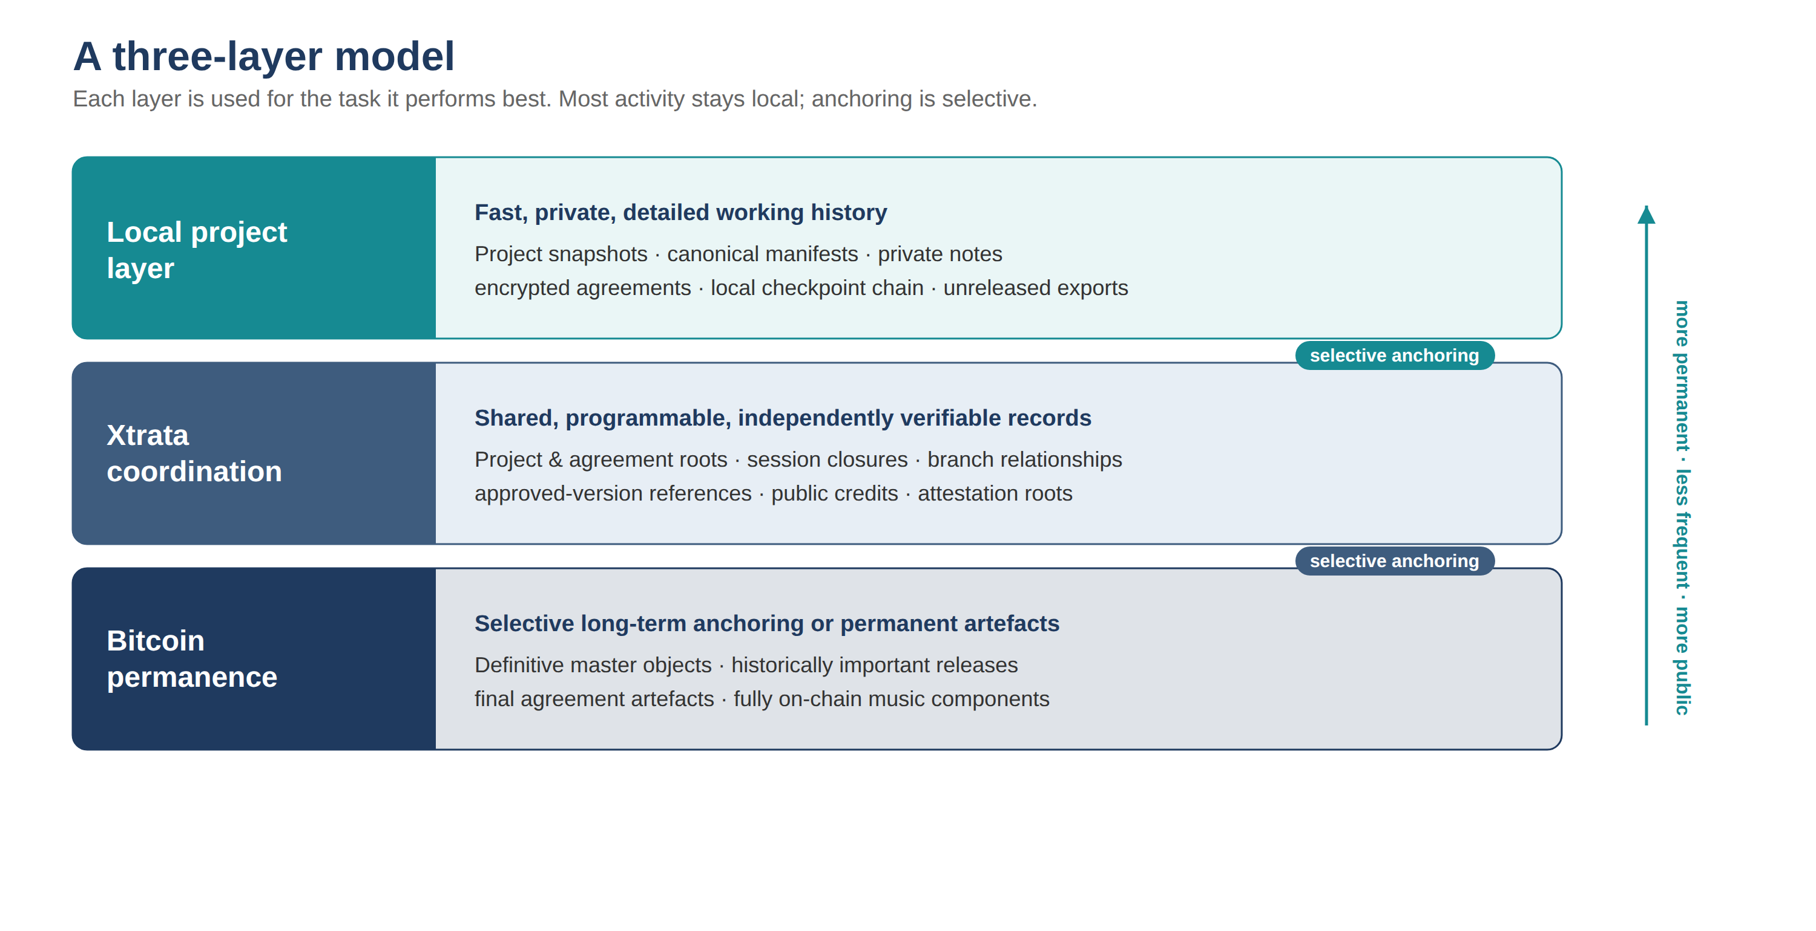
Figure 1. The three-layer model. Most activity stays local; the Xtrata layer coordinates shared, verifiable records; Bitcoin is reserved for selective permanence.
This hierarchy avoids two extremes. A purely local system can be altered without external evidence, while placing every action on Bitcoin would be expensive, slow and needlessly public. Each layer is used for the task it performs best.

3.1 Sponsored participation from the beginning
No participant should buy a token before confirming a session or approving a split. The default flow uses sponsored transactions: participants sign the exact action while Xtrata or the organiser pays the network fee, and multiple signatures can be aggregated into one transaction. The experience should say “Review and sign,” not “Fund your wallet.” This is a central adoption requirement, not a convenience — but because sponsorship is a real cost that scales with activity, Section 17 treats it as a managed expense rather than a permanent invisible subsidy.

4. Worked example: one project from first session to release
A fictional project shows how the parts fit and what stays local, shared or anchored at each step.
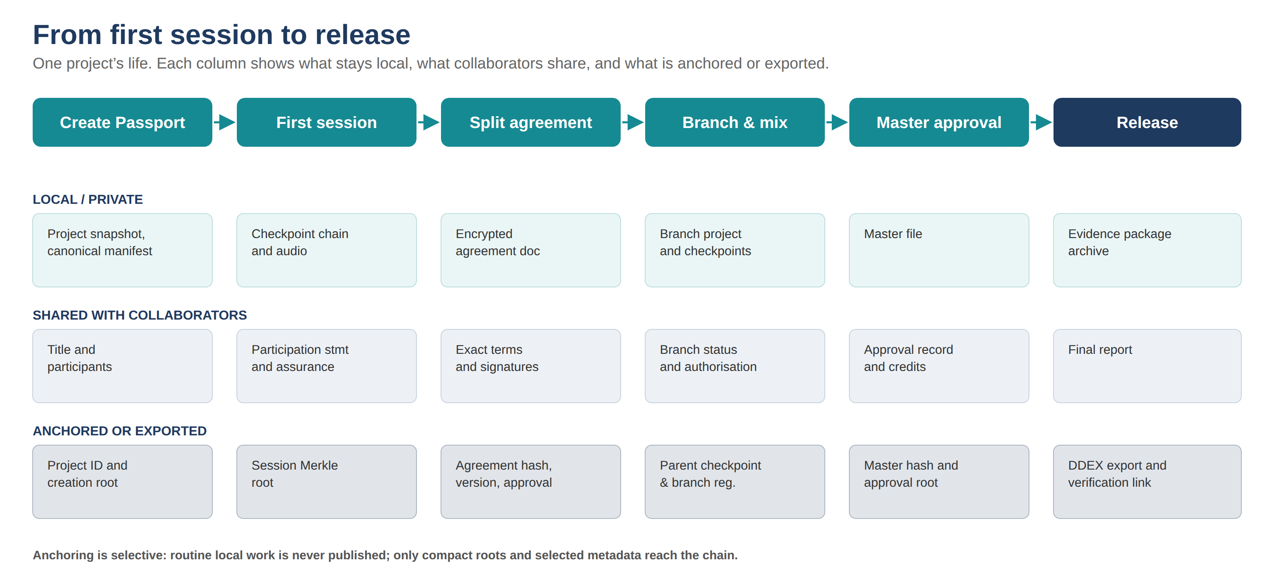
Figure 2. “Signals at Dawn,” from first session to release, showing the local, shared and anchored record at each stage.
Maya starts a project in a supported DAW and creates a Passport; Xtrata records the identifier, DAW and adapter versions, an exact snapshot hash, a canonical state manifest and a timestamp. Leon and Priya join by QR code. Maya signs with a hardware wallet and Leon with a passkey — both cryptographically controlled — while Priya first uses a verified email. The interface does not show three identical ticks: it shows two cryptographically-signed participants and one contact-confirmed, and the session record reads “Acknowledged by all; two cryptographically signed” rather than “Agreement approved.” Priya later adds a passkey linked to her original acknowledgement, raising her evidence profile without rewriting the earlier event.
During the session the adapter ignores cache and lock files, waits for stable saves, and records eleven canonical state changes rather than fifty-four raw file events. One plugin writes a fresh non-creative session identifier on every save; a validated component profile removes that tested source of nondeterminism from the canonical component while keeping the raw hash. At the end, Close Session produces a summary — attestations, first and final canonical hashes, a checkpoint Merkle root, an optional rough-mix hash — and one sponsored transaction anchors the compact session root.
A week later the three writers approve an equal composition split as Agreement Version 2, explicitly covering the composition and not the master, signed at the cryptographically-controlled level and labelled “legal identities not yet verified.” When producer Tariq later contributes a drum arrangement, Agreement Version 3 governs release-facing rights and therefore requires independently verified identity for the individual signers. Maya then branches a radio edit from checkpoint 42 with verifiable ancestry; the mixer returns Mix 7 and the collaborators approve its hash; a mastering engineer returns the final master with its own asset hash and approval record. Before release, the required rights holders complete identity verification, any label approval would require verified organisational authority, and Proof of Session generates a human-readable report, a machine-readable Passport export, a split-sheet package and a DDEX-oriented mapping — with any unmappable field flagged for manual review rather than silently dropped.

5. Project Passports and progressive agreements
Creative projects do not move directly from uncertainty to a final contract; they pass through stages of partial knowledge, and the protocol records that evolution rather than forcing an artificial early decision. At the lightest level participants acknowledge that they took part; at the other end they approve a detailed agreement covering ownership, royalties, producer points, fees, samples, confidentiality and dispute procedures. Between those points sit equal splits, custom percentages, credits, session terms and asset-specific permissions.
The interface must identify exactly what is being divided or approved. A 25 percent composition share is not 25 percent of the master; producer points are not composition ownership; public credit can be accepted independently of financial participation. Each agreement is an immutable versioned object: a new version may supersede an earlier one but never deletes it, and the record shows who proposed the change, what changed, which signatories and assurance threshold were required, who approved or declined, and whether it became effective. “Approved” is reserved for cases where every required signatory signed the exact version and met the configured threshold; weaker or partial results are described precisely rather than promoted to a green tick. Contribution notes such as “Leon wrote the chorus lyric” are evidence, distinguished as self-asserted, mutually confirmed or formally agreed — never converted automatically into a legal ownership determination. Disputed records remain in the history: a challenge or settlement creates a new record without erasing the fact that a disagreement existed.

6. Identity, authority and evidentiary strength
The value of “A, B and C signed” depends on who they are, how control of the signing method was established, whether they saw the exact terms, and whether they had authority to act. These are different questions, and the protocol keeps them separate. Assurance is stored as a multidimensional profile; the familiar A0–A4 label is only an interface summary derived from that profile, never a substitute for it and never a legal grade.
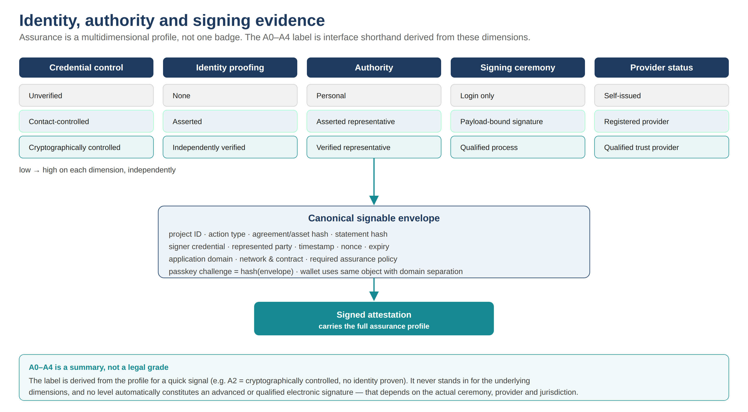
Figure 3. Assurance as a multidimensional profile. Each dimension moves independently; the A0–A4 label is derived shorthand, and no level automatically constitutes an advanced or qualified electronic signature.

6.1 Evidence dimensions behind the label
Every attestation records credential control (unverified, contact-controlled, cryptographically controlled), identity proofing (none, asserted, independently verified), authority (personal, asserted representative, verified representative), signing ceremony (login only, payload-bound signature, qualified process) and provider status (self-issued, registered provider, qualified trust provider). These do not collapse onto one axis. A wallet gives strong credential control while remaining pseudonymous; verified organisational authority is a different fact from verified personal identity. The label is convenience — for example, “A2” means cryptographically controlled with no identity proven — but the reopened-project view, exports and machine record always show the underlying dimensions, and every claim of verified identity or authority shows the verifier and profile that established it.

6.2 Payload-bound signing
A signature is only meaningful if it is bound to the exact thing signed. The protocol therefore defines a canonical signable envelope — project, action, agreement or asset hash, statement hash, signer credential, represented party, timestamp, nonce, expiry, application domain, network and contract reference, and required assurance policy — and every signature commits to it. For passkeys this means the authentication challenge is the hash of the envelope, so the assertion signs the agreement rather than merely proving the user logged in; for wallets it means signing the same canonical object with domain separation so a signature cannot be replayed as another action, project or application. The full envelope and its binding rules are specified in the companion Technical Specification.

6.3 Establishing and trusting verified identity and authority
Independently verified identity and organisational authority are not self-declared. Each is issued under a named, published Identity Provider Profile that records who performed the verification, the method and jurisdiction, the evidence checked, how the identity was bound to the credential, the verification date, any expiry, and the revocation route. The Passport stores the issuer, profile version and status; personal documents stay with the verifier. A rights body or court is never asked to trust an unexplained Xtrata badge — it can see which verifier made the claim, under which profile, and apply its own acceptance policy. Xtrata may offer verification early, but its own assertion must not be self-authenticating; the provider registry should admit qualified trust services, specialist identity providers, professional-register checks, notarial or legal verification, and direct verification by an accepting publisher or rights body.

6.4 Thresholds, provider dependency and progression
Every agreement sets a minimum assurance threshold according to consequence. Cryptographic control is a reasonable default for acknowledgements and provisional agreements among people who know each other, but it does not prove a legal name; release-facing assignments, high-value splits, master-rights transfers and agreements involving minors should require independently verified identity for each individual, and actions taken for a company should require verified organisational authority. Because verified identity and authority depend on external providers, they carry real cost, latency and coverage limits and sit on the critical path to downstream acceptance; the protocol treats provider coverage as a first-class dependency, supports multiple providers, and — where no qualified provider is available to a participant — records the agreement at the highest achievable level and exposes the identity gap rather than presenting it as fully verified. Identities can be strengthened over time, and an upgrade links the earlier claim to the stronger credential without rewriting the historical fact that the original action occurred at a lower level. Representatives, guardians and organisational signers are modelled explicitly, and compromised credentials trigger rotation and revocation without erasing earlier valid signatures.

7. Deterministic project state and canonical hashing
Deterministic project hashing is the load-bearing engineering problem. Every claim of verified continuation, branch ancestry or state identity depends on a stable representation of the project: if harmless cache changes trigger warnings, users stop trusting verification; if genuine edits are normalised away, the evidence is incomplete. The protocol therefore separates exact file identity, canonical project state and user-facing significance, and it is tested for reproducibility and for coverage — not treated as a solved parser.
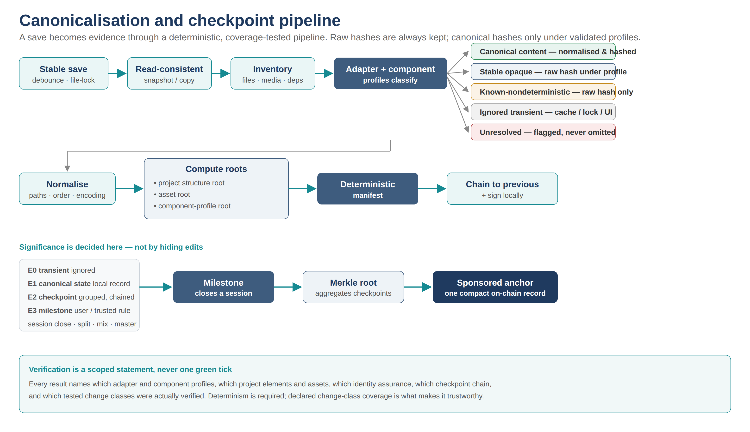
Figure 4. The canonicalisation and checkpoint pipeline. Raw hashes are always retained; canonical hashes are produced only under validated adapter and component profiles.

7.1 Three proofs, and honest coverage
Three complementary proofs are kept: an exact snapshot hash (identical bytes), a canonical state hash (a normalised representation under a tested DAW adapter), and an asset root with a human-readable event summary. Canonicalisation follows published rules — project-relative paths, deterministic ordering and encoding, conservative normalisation — and each opaque plugin component keeps a raw hash, gaining a canonical hash only under a validated component profile that has demonstrated, through repeat-save and cross-machine tests, which fields are nondeterministic and non-creative. Unknown bytes are never loosely ignored to preserve a green status; an unstable component reduces the verification scope instead. Significance is decided at the checkpoint and notification layer, so a two-millisecond region move still changes the canonical hash — small creative edits are not hidden.
A conformance corpus establishes declared change-class coverage, not proof of complete capture. Determinism is necessary but insufficient: a reproducible hash still under-captures state if an adapter silently omits a meaningful field, so the corpus must also assert that for each known class of creative change, an edit in that class produces a distinct hash — and any change class not yet covered is published in the adapter support matrix. A validated adapter therefore demonstrates deterministic behaviour and change detection across its published scope; it does not claim semantic coverage of undocumented fields outside that scope.

7.2 Adapters and component profiles as living infrastructure
An adapter is a maintained compatibility product, not a one-off deliverable. DAW and plugin vendors ship updates frequently and users often adopt them before an adapter is revalidated, so the service publishes adapter states (Monitored, Candidate, Validated, Maintenance, Deprecated) with the exact builds covered. A realistic commitment is robust support for a narrow set of current stable versions; when users run ahead of coverage, exact-snapshot and asset evidence still work while canonical interpretation visibly degrades. Maintenance, test machines, licences and rapid-response engineering are recurring costs budgeted as core infrastructure, and coverage is measured by the share of active projects on validated adapters and the time from a DAW release to validation — not by the number of logos on a website. The full pipeline, inclusion and exclusion profiles, event classes and support-matrix schema are specified in the companion document.
Engineering rule Verification is never one green tick. Every result names which adapter and component profiles, which project elements and assets, which identity assurance and which checkpoint chain were verified — and against which set of tested change classes.

8. Checkpoints, lineage and branching
Music projects fork constantly — radio edits, remixes, clean versions, alternates — so copying is treated as lineage, not misconduct. Each checkpoint records the canonical state hash, exact snapshot where available, asset root, previous-checkpoint reference, adapter and component-profile versions, timestamp, signer reference and local signature; linking each to the last makes removal or alteration visible. A chain can stay local until a session or milestone closes, at which point it aggregates into a Merkle root so any checkpoint can later be proven included without publishing the intermediate states.
Lineage is reported honestly: verified continuation, verified branch, unverified continuation, file-level relation only, or unrelated. One status is deliberately worded with care. The system can tell that a branch was not approved under the current Passport policy, but it cannot know that no valid off-system permission exists — so the state is “Not approved under the current Project Passport policy,” not “unauthorised.” Removing the .xtrata file ends the recognised chain at the last verified checkpoint without erasing anchored history; if the project re-enters later, the system describes the relationship it can actually establish rather than assuming seamless continuation.

8.1 Project state versus audible output
A project’s state and its audible output are not the same thing: the same project may render differently because of plugin nondeterminism, missing sample libraries, or operating-system and hardware changes. At selected milestones — approved mixes and masters especially — Proof of Session therefore records an approved reference render as a first-class object: the exact exported-audio hash, the render environment, an optional stem-set root, and optional human approval of the audible result, alongside the project-state evidence. This lets a later party verify not only that the project matched, but that a specific sounding master was the one approved.

9. Selective anchoring and why Xtrata
Xtrata is a Stacks-based infrastructure and inscription protocol for structured, composable on-chain records with a path to Bitcoin-backed permanence. The name must be read at three levels that are related but not interchangeable. Xtrata the application and company builds the experience, may sponsor transactions and may offer optional services. The open Xtrata protocol defines the Passport schemas, contract interfaces, registries and verification rules that others can reimplement. The underlying Stacks and Bitcoin networks are where public anchors persist. The company can fail without erasing valid chain records — but independent verification also requires the portable evidence package, open protocol versions, contract identifiers and a working verifier, so the durability argument depends on which of the three is assumed to persist.
The on-chain requirement is modest in volume but richer than a bare timestamp: inexpensive structured records, programmable state transitions, participant attestations, agreement and branch references, sponsored transactions, open verification and an optional route to Bitcoin permanence. Pure timestamping cannot express that one agreement superseded another, that a branch descends from a specific checkpoint, or that required signers met a threshold; a single central database would make verification depend on one provider’s survival; and placing everything on Bitcoin would be costly, slow and over-exposed. The choice of Xtrata is a requirements fit rather than a claim that no alternative could work, and the protocol stays exportable enough that users are not trapped. Assumptions about contract upgradeability, replay protection, transaction finality, chain reorganisation, sponsor downtime and self-submission fallback are set out in the companion specification, since the “independently verifiable” claim depends on them as much as on local hashing.

10. Privacy, encryption and data protection
A provenance system for unreleased music fails if it treats transparency as universal publicity. Public verification is separated from access to content: the chain can prove that a document, state or asset existed and was approved without revealing the item. Public records may hold an identifier, published credits, a release hash and selected lineage; collaborator-only records may hold proposed splits, approval status and checkpoint summaries; restricted records — financial terms, contact details, unreleased lyrics and audio, negotiation history, disputes — stay encrypted. Sensitive records are encrypted at rest with project-specific keys, and a verifier can confirm integrity without being authorised to read the content.
Two honesty points shape the design. First, revocation is bounded: access to future, server-mediated disclosure can be revoked, but a key or copy already received by a collaborator cannot be recalled — the interface must say so rather than imply otherwise. Second, a genuinely local-first system needs a real key architecture (per-project master keys, per-object keys, envelope encryption for collaborators, device enrolment, rotation, recovery and collective escrow, and defined treatment of departed collaborators); the design is specified in the companion document, and the commitment here is that Xtrata cannot silently read project content and that offline evidence packages remain verifiable if Xtrata disappears.

10.1 Data-protection governance
Identity verification introduces a data-protection workstream distinct from cryptographic privacy. Depending on provider and method it may involve identity documents or biometric data, engaging obligations around lawful basis, retention, controller and processor roles, transparency and, where risk is elevated, a data-protection impact assessment. Proof of Session treats privacy as both an encryption problem and a governance problem: identity evidence should be minimised, held under a defined lawful basis and retention policy, and — wherever possible — retained by the verifying provider rather than duplicated onto the chain or into the Passport, which stores only the profile reference and status.

11. Interoperability and downstream recognition
A split, credit or master approval becomes materially more useful when the wider rights ecosystem can recognise and consume it, so downstream recognition is a headline objective rather than a future footnote. The north-star outcome is that a verified Passport can move into at least one real publisher, label, distributor, collecting-society or rights workflow without the agreed data being manually re-keyed.

11.1 Build on DDEX, do not reinvent it
Proof of Session should not invent studio metadata. DDEX already standardises it — in particular the Recording Information Notification (RIN), designed to communicate data about studio sessions, contributors, roles and the works and recordings created, and intended for use inside DAWs and studio software. The right posture is to add verifiable identity, signatures, versioned agreement evidence, project-state lineage and independent anchors around these established structures, and to map Passport objects onto the relevant DDEX families rather than to a vaguely “DDEX-oriented” format. “DDEX-compatible” should mean a documented, validated mapping; where a receiving system needs data the Passport does not yet hold, the export flags the gap for completion.
Xtrata information | Primary external pathway
Studio participants, roles, sessions and creations | DDEX RIN (Recording Information Notification)
Contributor and party identity enrichment | DDEX PIE (Party Identification and Enrichment)
Composition shares and work-rights information | DDEX MWDR / MWN, where applicable
Recording contributors and recording-rights claims | DDEX RDR-N, where applicable
Release and resource delivery metadata | DDEX ERN, or the partner’s release workflow
Xtrata-specific evidence | Extension, linked evidence package or verification reference

What Xtrata contributes beyond RIN is precisely what RIN does not carry: signed participant attestations, multidimensional assurance profiles, versioned agreement evidence, canonical project-state references, branch lineage, approval policies, tamper-evident history and public verification receipts. A direct conversation with DDEX should be a Phase 0 objective, not merely a later pilot, so the mapping is validated against the real standards from the outset.

11.2 Export package and recognition milestones
Exports include a human-readable evidence report, a machine-readable Passport, a split-and-credit export, the DDEX mapping, an encrypted evidence package for legal contexts, and a public verification link. Recognition is measured by concrete outcomes — an external rights organisation validates the schema, a release partner ingests credits without re-keying, a publisher accepts a split export, and an independent verifier reproduces the result — and these are prioritised ahead of deep integration across many DAWs. ISRC, ISWC, IPI, ISNI, UPC and catalogue identifiers are attached as they appear, enriching the original project identity rather than replacing it.

12. Project governance and policy authority
The agreement model is only trustworthy if it is clear who may set and change a project’s rules, not just how individual agreements evolve. Proof of Session therefore defines a project’s governance explicitly, beginning with a signed genesis policy created with the Passport.
The genesis policy names roles — initiator, controller, collaborator, rights approver — and separates operational actions (opening and closing sessions, creating checkpoints) from rights-changing actions (adding or removing a required signer, altering splits, setting or lowering an assurance threshold, designating a release master). Creating the Passport makes the initiator the initial controller, but the initial participant list and any change to required signers must itself be confirmed under the policy. A crucial rule: a policy change cannot set an assurance threshold lower than the one in force without explicit, prominently disclosed action, so a controller cannot quietly weaken protection immediately before an approval. The active policy version is stamped into every agreement, branch and asset approval, so later changes never retroactively alter earlier authority.
The policy also defines what happens when reality intrudes: recovery and succession when a controller must be replaced; deadlock and absent-signer states when a collaborator disappears; treatment of death, incapacity, company dissolution or lost credentials; visible emergency actions that never silently alter rights; and handling of a disputed controller claim, which is recorded as a live dispute rather than resolved by fiat. Changing the quorum requires meeting at least the quorum being changed. None of this is an edge case — together it determines whether the agreement model can be relied upon at all.

13. Security and threat model
The protocol must protect integrity and confidentiality against altered files, deleted history, impersonation, compromised devices, stolen credentials, malicious branches, false contribution claims, private-agreement disclosure and service-provider failure. Linked checkpoints expose missing or modified history; signatures bind participants to exact payloads through the signable envelope; Merkle roots allow compact anchoring and later inclusion proofs; version-pinned adapters and component profiles make canonical scope reproducible; approved assets are identified by content hash, not file name. Sensitive records are encrypted locally and in backup, public anchors carry only hashes and minimal metadata, and recovery does not require the provider to read content. Passports remain recoverable through encrypted backups, collaborator recovery, wallet or passkey recovery and exported packages, and public anchor receipts identify the network, contract and protocol version so another implementation can retrieve and verify them independently. Some threats are beyond technology: a group can still agree to false information, a signer can later dispute understanding, a compromised device can produce a valid signature. The system reduces ambiguity and preserves evidence; it does not claim that cryptography removes human conflict.

14. Legal and evidentiary boundaries
Proof of Session can support electronic agreements and evidence trails, but its legal effect depends on wording, identity, authority, jurisdiction and surrounding facts. “Approved” is a protocol state, not a declaration of enforceability.

14.1 Evidence dimensions, not legal grades
Earlier drafts mapped the A-levels onto legal signature tiers. That was a mistake, and it is corrected here. The protocol records evidence dimensions — credential control, payload integrity, signer intent, identity proofing, representative authority, trust-service or provider qualification, and the applicable jurisdiction — and reports them plainly.
Stated plainly A0–A4 are protocol assurance descriptors, not legal signature classifications. No Xtrata level automatically constitutes an advanced or qualified electronic signature.
An Xtrata record may contribute evidence toward a basic, advanced or qualified signature process, but only where the actual ceremony, technology, identity process and provider satisfy the applicable legal requirements. Those requirements are cumulative and specific — for example, a qualified electronic signature under eIDAS additionally requires a qualified certificate and a qualified signature-creation device, and organisational authority is a separate question from whether a signature is advanced or qualified — and other frameworks, such as the US ESIGN Act, do not provide an ascending tier system at all. The product must therefore never assert a legal tier automatically; it records the verifier, profile and evidence so that a relying party, or its lawyers, can determine which legal pathway was actually satisfied.

14.2 What it does and does not establish
Depending on adapter, assurance and agreement design, the record may help establish that a state existed by a certain time, that named credentials signed an exact statement, that an agreement version was approved, that a project descends from a recognised checkpoint, that a mix or master was authorised, or that local history was altered. It does not inherently prove that a participant told the truth, was physically present, created a specific melody, made an imported file independently, lawfully obtained a sample, understood complex terms, or that percentages are enforceable everywhere. Every verification report pairs the claim with its scope — for example, “Canonical state verified under Logic adapter version X against the standard change-class corpus” or “Identity-verified approval by two signers under provider profile Y” — and avoids phrases such as “ownership proven” unless a qualified legal process has made that determination. Complex publishing, master-rights, employment, sample, minor and cross-border agreements should be reviewed by qualified professionals, with template provenance and versioning recorded.

15. Open standards and independent verification
Proof of Session should be credible beyond one company. The Passport schema, canonicalisation rules, assurance vocabulary, identity-provider profile framework, signature envelope, verification library and conformance fixtures should be public; private application code may remain proprietary, but the evidence format cannot be a black box. Governance is required for schema upgrades, deprecated adapters, identity-provider profiles, template registries, dispute markers and compatibility certification, and no governance process may rewrite a valid historical record — it may deprecate a standard for future use, but not alter the past.

15.1 Registry governance for independent verification
Independent verification is only as strong as the registries it depends on: adapter versions, component profiles, identity-provider profiles, contract references, schema versions and revocation lists. The paper commits to a governance model in which these registries are cryptographically signed, versioned and archived, so that a verifier can resolve which profile was valid at the time a record was signed rather than trusting the latest hosted response. A verifier must be able to confirm historical evidence against a point-in-time registry state — using signed, append-only registry logs and archived snapshots — without automatically trusting a live Xtrata endpoint. The detailed registry and revocation model is set out in the companion specification; the commitment in this paper is that historical validity is resolvable and that no single live endpoint is a trusted oracle.

16. Product architecture and roadmap
The initial product is a DAW-independent desktop companion with optional lightweight in-DAW panels, reducing dependence on official platform support while the difficult evidence, identity and agreement layers mature. The companion creates Passports, monitors folders, runs adapters and component profiles, maintains checkpoints, handles encryption and signing, sponsors transactions, creates branches, verifies projects and exports evidence; it is the authoritative local coordinator but not the sole verifier. Core data objects and the smart-contract surface are defined in the companion specification.

16.1 Vendor cooperation and the adapter burden
Maintaining adapters purely by observation and reverse engineering could become the company’s dominant engineering cost. The roadmap therefore actively pursues vendor cooperation: seeking a documented export or project-manifest interface, engaging at least one DAW vendor, using an open or well-documented project format as a test bed, publishing an adapter SDK so vendors or third parties can maintain profiles, and moving toward certification rather than Xtrata maintaining every adapter itself. Reducing the long-run adapter burden is treated as a strategic objective, not only an engineering task.

16.2 Roadmap and gates
Phase 0 builds the foundations — canonical specification, adapter and component-profile conformance suites, the assurance and identity-provider frameworks, the signature envelope and an open verifier — and, in parallel, opens the DDEX conversation and maps Passport data to at least one downstream workflow. A tightly scoped Phase 1 pilot on a single locked DAW/version may run concurrently, making no public canonical-verification claim beyond that target, so the team learns from real sessions without waiting years. Phase 1 ships the Passport and session proof; Phase 2 adds agreements, credits, risk-based thresholds and the DDEX-RIN mapping behind two gates — a product gate (the mapping validates and an independent party reproduces the result) and an ecosystem gate (a partner completes an intake pilot or signs a scoped commitment), with downstream-acceptance claims held until the ecosystem gate is met. Later phases add lineage and approved assets, deeper DAW integration, rights and payments, and asset-level and Xtrata-native production, each degrading visibly when unsupported.

17. Adoption and business model
The first adoption goal is behavioural, not financial: make a basic Passport and session acknowledgement easy enough to become normal studio practice, creating value before every collaborator signs a complex contract. The system has a genuine two-sided cold-start — the first collaborator gains less if others will not sign, and a studio record gains less if downstream systems still re-key everything — so low friction alone does not solve it.

17.1 The sharpest wedge first
The strongest initial beachhead is a coordinated environment with an existing release pipeline: professionally organised songwriting camps and independent-label recording sessions, where several writers participate, a host coordinates, split and credit needs are immediate, a downstream partner already exists, and willingness to pay is higher than in hobbyist use. In these settings one trusted host makes the workflow normal for everyone — closing each session with a Passport summary, sponsoring the transaction, and giving every participant an immediate evidence report — so collaborator number one is never asked to adopt alone. Community studios, schools and remote collaborators remain valuable adoption channels, but the camp-and-label segment is the best early proof that downstream rights systems will accept the records. The sequence runs from coordinator-led capture, to repeated creator use, to release-package exports, to downstream intake partnerships; each side gains value before the whole network is complete.

17.2 Illustrative operating economics
Sponsorship, identity verification and adapter maintenance are real per-event and ongoing costs, and the model must show that a frictionless experience is economically supportable. The figures below are illustrative ranges to frame the model, not forecasts; actual costs depend on chain conditions, providers and scale.
Cost line | Illustrative basis | Design response
Sponsored session anchor | Fraction of a cent to a few cents per aggregated transaction | Aggregate many signatures into one anchored root; anchor milestones, not saves.
Participant signature | Near-zero marginal (passkey/wallet) | Free at entry; no token required.
Identity verification (individual) | Several to tens of currency units per verified identity | Charged to release-grade parties who need it; reused across projects.
Organisational authority verification | Higher, periodic re-verification | Enterprise and label tiers; profile reused across a catalogue.
Bitcoin-level permanence | Materially higher per inscription | Reserved for definitive artefacts and milestones only.
Adapter / profile maintenance | Recurring engineering per DAW-version family | Offset by vendor cooperation, SDK and certification (§16.1).
Storage and encrypted backup | Per-project, ongoing | Paid studio, label and enterprise tiers.

Revenue comes from professional and studio subscriptions, enterprise rights administration, sponsored-transaction and verification packages, encrypted backup, templates, API access, white-label integrations and permanent-inscription services — never from charging every participant a blockchain fee. Sponsorship is offered within paid tiers rather than as an unlimited subsidy, and the unit economics of a sponsored session and a verified release should be understood before scaling promotion.

18. Risks and mitigations
Risk | Why it matters | Mitigation
Hashing noise or missed change | False warnings destroy trust; silent omissions weaken evidence. | Version-pinned adapters and component profiles, dual hashes, and a corpus testing determinism and declared change-class coverage.
Assurance mistaken for legal proof | A polished badge could imply legal weight it lacks. | Multidimensional evidence dimensions, explicit “not a legal grade” statement, verifier and profile shown, no automatic tier claims.
Signature not bound to the agreement | A passkey could prove login, not consent to terms. | Canonical signable envelope; passkey challenge commits to it; wallet domain separation against replay.
Identity-provider dependency | Release-grade identity depends on external providers’ cost and coverage. | First-class dependency; multiple providers; expose identity gaps; charge release-grade verification to parties who need it.
Weak project governance | Unclear authority to set or change rules undermines agreements. | Signed genesis policy; separated action types; thresholds cannot be silently lowered; succession and deadlock rules.
Data-protection exposure | Identity verification involves sensitive personal or biometric data. | Minimisation, lawful basis and retention policy, provider-held evidence, DPIA where risk is elevated.
DAW and plugin churn | New builds and nondeterministic payloads delay canonicalisation. | Published support matrix, recurring maintenance, component profiles, vendor cooperation and file-level fallback.
Verifier trusts a live endpoint | A moving registry could rewrite historical validity. | Signed, versioned, archived registries; point-in-time resolution; no single live oracle.
Cold-start / two-sided adoption | First movers gain less before the network exists. | Coordinator-led camps and label sessions; immediate evidence for all; exports and partner pilots in parallel.
Sponsorship cost at scale | Unbounded fee and verification subsidy is unsustainable. | Aggregation, milestone-only permanence, tiered sponsorship, understood unit economics.
Service or chain failure | A central app or layer could disappear. | Open schema, portable packages, independent verifier, anchors identified by network and contract.
Blockchain rejection | Some creators avoid crypto-branded workflows. | Music-first language, invisible fee sponsorship, benefits independent of speculation.

19. Broader vision and conclusion
Proof of Session begins with a narrow intervention: create a shared Passport when work begins, attach a full assurance profile to every attestation, preserve project state through deterministic and coverage-tested verification, and anchor only the milestones that benefit from independent proof. If that foundation is reliable, the Passport can follow a work through writing, production, mixing, mastering, artwork, publishing, distribution, licensing, sampling, remixing and archiving, so credits and rights develop alongside the creative object instead of being reconstructed afterwards.
Everything in the paper reduces to four layers of trust. The technical layer must produce deterministic, coverage-tested project evidence. The operational layer must maintain adapters and component profiles as DAWs and plugins change. The identity-and-authority layer must state who signed, how their control and identity were established, whether they had authority, and under which provider — never as one escalating badge, and never as an automatic legal grade. The commercial layer must produce records the downstream industry can consume, built on DDEX rather than reinvented. None can be replaced by marketing language, and the single most important discipline is to show exactly which technical, identity, authority, legal and project-state claims have actually been established, rather than presenting assurance as one green tick.
Proof of Session does not replace the creative process. It gives it a memory — one that begins as a simple shared record, grows stronger through signatures and agreement, stays private where it should, and travels with the work until the final release can be traced back to the people and project history from which it emerged.
Final proposition A small change at the beginning of a project can prevent large uncertainty at the end: record who was involved, what was agreed, which evidence supports that agreement, and how the work developed.

Appendix A. Verification status vocabulary
Status | Required evidence
Exact Snapshot Verified | The captured package hash matches an anchored or signed reference.
Canonical State Verified | A validated adapter reproduced the canonical state hash, dependencies resolved, and the tested change-class corpus was satisfied.
Canonical State Partially Verified | The supported state matched, but a dependency or opaque component is unresolved or unstable.
File-Level Continuity Only | Linked through exact package or file evidence; canonical interpretation unavailable.
Checkpoint Chain Interrupted | The current state cannot be connected to the last recognised checkpoint without a gap.
Agreement Acknowledged | All named participants responded, but one or more did not meet the approval threshold.
Agreement Approved | Every required signatory signed the exact version and met the configured threshold.
Approval Disputed | A participant or authorised party has recorded a live challenge.

Appendix B. Initial acceptance criteria
A first public release should not claim success merely because a transaction can be written. These criteria make the commitments falsifiable.
- The same supported project produces identical canonical manifests across at least two machines and repeated saves when creative state is unchanged.
- Controlled creative changes produce changed canonical hashes, including small edits not filtered as noise.
- For each known class of creative change, an edit in that class produces a distinct canonical hash; any change class not yet covered is published in the adapter support matrix.
- Repeated saves of an unchanged project with a profiled nondeterministic plugin produce a stable result; unprofiled or unstable components visibly reduce verification scope.
- Unsupported DAW versions degrade visibly to file-level proof without showing canonical verification.
- Every signature displays its assurance profile; every verified-identity or authority claim displays its verifier and provider profile.
- A signature verifiably commits to the canonical signable envelope for the exact action, project and agreement, and cannot be replayed elsewhere.
- An agreement cannot be labelled Approved unless every required signer meets the configured threshold; release-facing agreements require verified identity, and organisational actions verified authority, unless a lower policy is deliberately and prominently disclosed.
- A complete session is signed and anchored without any participant holding a token.
- An independent verifier reproduces the public result from the portable package and anchors, resolving registry entries to their point-in-time state.
- At least one downstream rights or release partner completes an intake test of the DDEX-based export, or signs a scoped pilot commitment, before any claim of acceptance.

Appendix C. Glossary
Term | Meaning
Assurance profile | The multidimensional record (credential control, identity proofing, authority, signing ceremony, provider status) behind the A0–A4 interface label.
Canonical signable envelope | The canonical object a signature commits to, binding a signature to a specific action, project and agreement; detailed in the companion specification.
Canonical state | A deterministic, normalised representation of a supported DAW project, tested for completeness against declared change classes.
Component profile | A tested normalisation and verification profile for a plugin or proprietary component, retaining a raw hash.
Genesis policy | The signed project-governance policy created with the Passport, defining roles, action types, thresholds and succession.
Identity Provider Profile | A published, versioned description of who performs a verification, the evidence and authority checks used, and how a claim is bound, expires or is revoked.
Project Passport | The portable identity and evidence history of a creative project.
RIN | DDEX Recording Information Notification: the standard for studio-session, contributor and creation metadata that Xtrata builds around.
Sponsored transaction | A transaction signed by the participant but paid for by Xtrata or another sponsor.
Xtrata application / protocol / chain | The company and product, the open reimplementable evidence specification, and the Stacks or Bitcoin networks where anchors persist — related but not interchangeable.

